V3 – January 2021

Well Baby Nursery
Guidebook

Contents
Normal Newborn Vital Signs: 4
Delivery Room 4
APGARS 4
Criteria for Peds to be Called to Deliveries 4
Fetal Monitoring 5
Admission Criteria for the NICU 6
Delivery Room Preparation 7
NRP – Neonatal Emergency Medications 7
NRP Algorithm 9
Bilirubin 10
Hyperbilirubinemia Risk level 10
Risk to Develop Jaundice – 10
Hyperbilirubinemia Follow up guidelines 10
Olive View Specific Bilirubin Monitoring 11
Cardiology 12
Dusky Spell/Perioral Cyanosis 12
Murmur 12
Irregular Heart Beat 13
CCHD Algorithm (From CDC.gov) 13
Dermatology 14
Rash/Petechiae 14
Ruddiness 15
FEN/GI 15
Breastfeeding 15
Diaper Count 17
Hypoglycemia 17
Bloody Stool 17
Emesis 18
No stool (24 hours) 18
Genetics 19
HEENT 19
Microcephaly 19
Caput/Cephalohematoma/Subgaleal 20
Short Tonuge/Tongue Tied 20
Eye Discharge 20
Hematology 21
Polycythemia 21
Infectious Disease 21
Septic/Sick Neonate 21
Chorioamnionitis 22
Triple I 22
GBS Management 24
Hepatitis B 25
Hepatitis C 25
Rubella 26
Herpes 26
TB 27
HIV Management at OVMC 27
Syphilis 29
Temperature Instablity 30
Muskuloskeletal 31
Clavicle 31
Hips 31
Sacral Dimple 31
Neurology 32
Floppy/Poor Feeder 32
Seizure 32
Renal/GU 33
Bloody Urine 33
Hydronephrosis (Prenatal Diagnosis) 33
Abnormal Penis/Hypospadius 33
No Urine (24 Hours) 34
Scrotal Problems 34
Respiratory 35
Nasal Congestion/Can’t pass the NG TUbe 35
StRidor 35
Tachypnea 35
Social 36
Infant of Substance Abusing Mother 36
IUGR 37
Antibiotic Dosing 38
Growth Chart 39
Mommy Talk 40
Resources 41

Normal Newborn Vital Signs:

Temperature (Rectal) | 36.5 – 37.5
Heart Rate | 120-160 bpm
Respiratory Rate | 40-60 bpm
Oxygen Saturation | 1 min: 60-65% | 2 min: 65-70% | 3 min: 70-75% | 4 min: 75-80% | 5 min: 80-85% | 10 min: 85-95%

Delivery Room
RTs and NICU RNs will attend all deliveries for which Peds is called. NICU Attendings will serve as back-up to the PNP’s, who will serve as back-up to the Interns.

APGARS
Taken at 1 and 5 minutes after birth
Physical Exam | Score
Physical Exam | 0 | 1 | 2
Activity (Muscle Tone) | Flaccid, Limp | Some Flexion | Active movement, well flexed, MAEs
Pulse (HR) | Absent | <100 bpm | >= 100 bpm
Grimace (Reflex, Irritability) | No response to stim | Feeble cry when stimulated, grimace | Pulls away when stimulated, sneeze/cough
Appearance (Skin Color) | Blue-gray, Pale | Acrocyanosis | Pink
Respirations (Resp Effort) | Absent | Weak, Irregular | Good, strong cry

Criteria for Peds to be Called to Deliveries
Highest Risk  (NNP/Hospitalist/Neonatologist Present)  Delivery that will result in NICU admission and any of the following: | High Risk  (NICU RN, RT, Intern available)  Deliveries that might result in NIUC admission:
Crash/Emergency C/S | Vaginal Breech Delivery
Meconium with signs of fetal distress | Any C/S except crash/emergency
Fetal distress (sustained fetal bradycardia) | Clinically suspected/diagnosed chorio (direct admit to NICU)
EGA <35 weeks | Any maternal medication which can depress fetal respiration (Mag)
EFW < 2000 grams | Fetal decelerations, variables or lates; or fetal tachycardia
Any suspected congenital anomalies diagnosed prior to or after birth | Forcep assisted vaginal delivery
Multiples greater than twins | Intrauterine growth retardation if EFW <2,000 gm
Fetal Hydrops | Gestational DM
Suspected symptomatic major blood group isoimmunization | Fetal Macrosomia
APGARS <3 at 1 minute and <6 at 5 minutes | Meconium without signs of fetal distress
 | Oligohydramnios (if potter’s sequence not suspected)
 | Polyhydramnios (without major anomalies)
 | Maternal pregnancy-induced hypertension or pre-eclampsia
 | Prolonged rupture of fetal membranes > 18 hrs
 | Shoulder Dystocia
 | Twin gestations if GA >34 weeks and EFW >2000 grams
 | Vacuum assisted vaginal delivery

Fetal Monitoring
Cat 1 - Normal | Cat 2 - Intermediate | Cat 3 - Abnormal
- Baseline HR: 110-160 bpm  - Baseline FHR Variability: moderate  - Late of Variable Decels: Absent  - Early Decels: Present or absent  - Acels: Present or absent | Requires evaluation and surveillance  - Bradycardia (FHR <110) now accompanied by absent variability  - Tachycardia (FHR >160)  Minimal (0-5 bpm) or marked (>25 bmp) variability  - Absent variability w/o recurrent decels  - Absent induced acels after fetal stim  - Recurrent variable decels, minimal or moderate variability  - Prolonged decels  - Recurrent late decels w/ moderate variability | Predictive of abnormal fetal acid-base status and require prompt intervention  - Absent variability with any of the following: recurrent late decels, recurrent variable decels, bradycardia  - Sinusoidal pattern

Admission Criteria for the NICU
All admissions and care are under the supervision of the neonatologists.
NICU ADMISSION
- <35 week GA
- < 2000 grams
- Respiratory Distress:
- RR >60 or grunting at >60 min of life
- Requiring intubation and PPV in DR
- Apnea and Bradycardia
- Require O2
- Congenital Heart Disease
- Infant in shock defined as poor skin perfusion
- Apgar of 6 or less at 5 minutes
- Requiring exchange transfusion
- Requiring IVF, IV meds, TPN
- Infants with problems requiring close observation including those born to a mother with proven or suspected infection if symptomatic
- Infants with the following signs and symptoms:
- Seizures
- Abdominal distension
- Respiratory depression
- Ambiguous genitalia
- Abdominal masses
- Bloody stools
- Neonatal Abstinence syndrome
- Dehydration
- Infants with anemia (Hct, < 40% on DOL 1)
- Infants with polycythemia (central Hct. > 65%)
- Hypoglycemia defined as a blood glucose <26 or requiring glucose gel > 3 times for stabilization of blood sugars
- Other infants at the discretion of the physician
If a newborn is being admitted to the NICU you must do the following:
- Notify the neonatologist (x73949) of the admission to ensure that proper arrangements can be made.
- Notify the charge nurse (x74463) of the possible admission to ensure that proper arrangements can be made
- Notify the respiratory therapist as needed
- Examine and re-evaluate the infant’s condition
- Write an admission note, history and clinical findings within 24 hours.
- Write within one (1) hour of admission the admission orders to include: status, medication orders, lab orders, IV fluid orders, treatments and respiratory support.
- Speak with the parents regarding the infant’s condition and obtain written consent for common procedures from the parents for care.

Delivery Room Preparation
The following should always be on hand and set up:
  - Oxygen at 10L and 21% (FT) or 40% (preterm)
  - Check that Oxygen bag inflates and has a PEEP of 5. For BBO2, remember to increase FiO2 to 100%. For CPAP, usually a PEEP of 5 is safe, prolonged CPAP can increase risk of pneumothorax. For PPV, aim for PIP 20-25, PEEP 5, may need more PIP for preterm infants. RT will have intubation supplies available
  - Check vacuum (suction to 80-100)
  - Prepare
    - Warmer
    - Delee catheter
    - Bulb suction
    - Infant Hat/Blankets
    - Thermal mattress for preterm deliveries <32wks gestation, heat-retaining bag for preterm deliveries <28wks gestation
  - Timer should be started as soon as baby delivers. If baby is stable, delayed cord clamping can be done for 30-60sec. APGARs should be calculated at 1 and 5 minutes of life.
EMR tip: Documentation of APGARs can be done in mother’s chart under “Flowsheet”, under the tab “Newborn Delivery Data”. Clicking on the first box in the column will go through the options for APGAR assignment and resuscitation with resuscitation provider details.

NRP – Neonatal Emergency Medications
Medication | Dosing | Indication
Epinephrine 1:10,000  (0.1 mg/ml)  Rapidly Given | 0.1 – 0.3 mg/kg IV  0.3 – 1 mg/kg (ET) | Cardiac Stimulant  Give when HR <60 bpm despite good ventilation and chest compressions
Normal Saline  O-blood (slow over 5 – 10 min) | 10 ml/kg | Volume expansion  Baby in shock (Hx: extensive vaginal bleeding, abruption, placenta previa, twin/twin transfusion)
Narcan (1 mg/ml) | 0.1 mg/kg (IV works faster, can be given IM) | Narcotic reversal agent  Give if mom received narcotics w/in 4 hours of delivery

NRP Algorithm
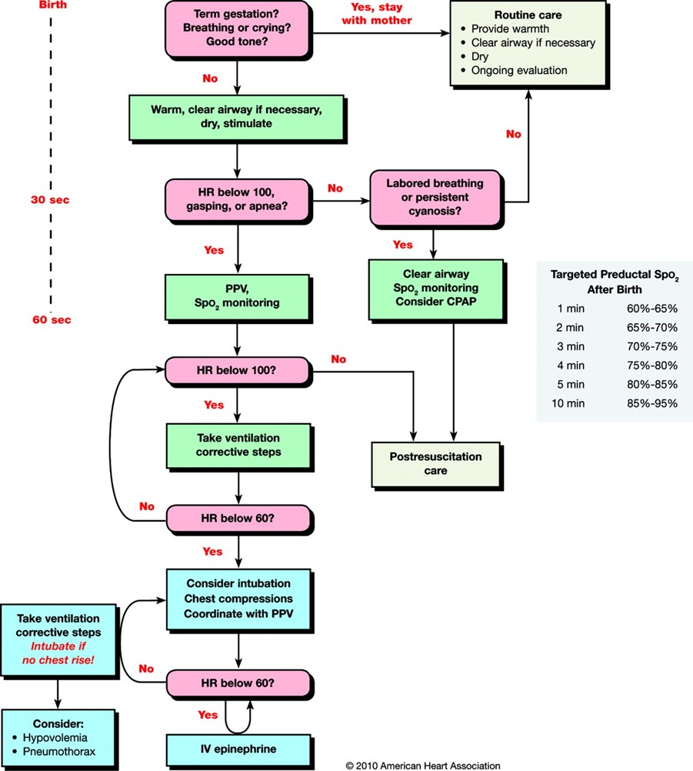

Bilirubin
Hyperbilirubinemia Risk Factors | Neurotoxicity Risk Factors
Lower gestational age (risk increases with each additional week less than 40 wk) | Gestational age < 38 weeks and this risk increases with the degree of prematurity
Jaundice in first 24 hours | Significant clinical instability in the previous 24 h
Hemolysis from any cause (including ABO incompatibility w/ + coombs) if known or suspected based on rapid rate of increase in the TsB/TcB of >0.3 per hour in the first 24 h or >0.2 per hour thereafter | Isoimmune hemolytic disease (ie, positive direct antiglobulin test or positive DAT), G6PD deficiency, or other hemolytic conditions
Predischarge transcutaneous bilirubin (TcB) or total serum bilirubin (TsB) close to phototherapy threshold | Albumin <3.0 g/dL
Parent or sibling requiring phototherapy | Sepsis
Cephalohematoma or bruising
Exclusive breastfeeding, especially w/ poor feeding or weight loss
Phototherapy before discharge
Family hx or genetic ancestry suggested of red blood cell disorder (G6PD) deficiency
Down Syndrome or Macrosomic infant of a diabetic mother

Risk to Develop Jaundice – Phototherapy Thresholds Without Neurotoxic Risk Factors and with Neurotoxic Risk Factors
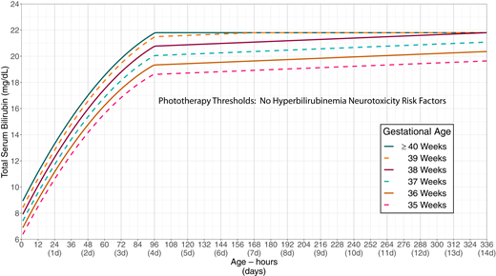

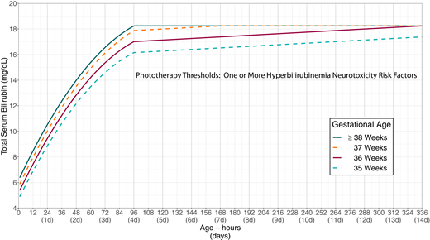
Decision to initiate phototherapy is guided by the gestational age, the hour-specific TsB, and the presence of risk factors for neurotoxicity (most commonly being DAT+).
Presence of neurotoxic risk factors lowers the threshold for treatment hence the separate phototherapy threshold chart (the chart shown above). For those without neurotoxic risk factors, we use the chart shown on the prior page.

Hyperbilirubinemia Follow up guidelines
Using the difference between TsB/TcB and the phototherapy threshold at the time of measurement, we can determine the interval between discharge and follow up (if you’re 4 mg/dL away from light level, a newborn should have a repeat TcB/TsB in 1-2 days).
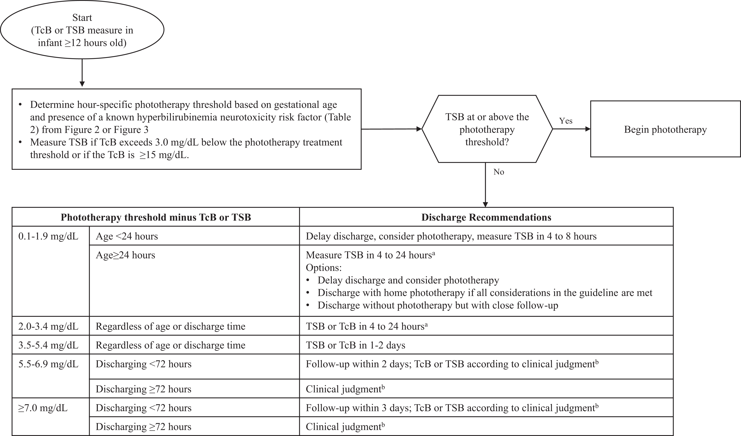

Olive View Specific Bilirubin Monitoring
In the Olive View Newborn Nursery, we are more conservative than the evidence-based guidelines. The reason for this is our population presents special challenges to management as they globally have poor medical literacy and are often lost to follow up.
- All babies (without ABO incompatibility) will have routine serum total and direct bilirubin at 24 hours of life (ordered Stat).
  - Phototherapy will be initiated following AAP phototherapy guidelines and only when at indicated light level
  - How often should you monitor TsB after starting phototherapy?
    - Every 12h -> no hemolytic disease or high rate of rise
    - Every 6-8h -> evidence of hemolytic disease or other neurotoxic risk factors or rate of rise >0.3 mg/dL/h
    - Every 2-4h -> within 1-2 mg/dL of exchange transfusion levels
  - Can discontinue phototherapy if TsB is at least 2 mg/dL below the hour-specific threshold at the initiation of phototherapy (ex. if you initiated phototherapy at a light level of 12, the TsB would need to be less than or equal to 10 for you to discontinue lights).
  - If the TsB is within 2 mg/dL or at exchange transfusion level, transfer to NICU
  - Which newborns require a rebound bilirubin 6-12 hours after lights are turned off?
    - Required phototherapy during birth hospitalization and
      - Required phototherapy before 48 hours of age OR
      - Have a positive DAT OR
      - Had known or suspected hemolytic disease OR
      - Phototherapy discontinued sooner than 2 mg/dL of ptx initiation threshold
  - All infants who received phototherapy during their nursery course should have a TsB measured the day after phototherapy was discontinued
- ABO Isoimmunization Hyperbilirubinemia Protocol
  - Immediate Cord Bilirubin
    - Normal <2.1
    - Start phototherapy automatically if cord bilirubin >=4
    - Consider q6h-q8h Ts bili for first 24h
      - If no phototherapy required before 24 HOL, can use TcB for bilirubin screenings at 48 or 72 HOL (if newborn is still admitted)
      - If a TcB is ≥ 12 mg/dL, please obtain a TsB as it may be off by ± 3 (TsB may be ≥15 mg/dL though the meter is reading it as 12 mg/dL)
    - If rate of rise >0.3 consider starting phototherapy
    - If rate of rise >0.5 admit to NICU for phototherapy, IVF, etc
    - If bilirubin is approaching exchange transfusion thresholds or has a rapid rate of rise with concern for hemolysis, can obtain a CBC, retic count and peripheral smear.

All bilirubin levels should be ordered STAT

Cardiology

Dusky Spell/Perioral Cyanosis
Considerations:
- Central or peripheral cyanosis?
- Is baby currently cyanotic?
- What was baby doing when it became cyanotic? (Feeding?)
- Who witnessed the event?
- Is there a murmur? Are pulses ok? Hepatomegaly?
Differential:
- Reflux, sepsis, hypoglycemia, cardiac lesion, arrhythmia, pulmonary pathology, seizure, esophageal atresia
Possible Plan:
- Check pulse ox
- Check blood sugar
- Chest XR
- Sepsis work up
- Call NICU (especially is persistent cyanosis – consider pneumocardiogram, hyperoxia test, EKG, ECHO)

Murmur
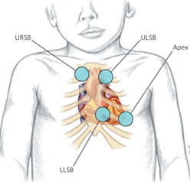
Considerations:
- Check vitals and WOB
- Listen to all four spots on with bell and diaphragm
- Listen for radiation of murmur to axilla (PPS, PS), back (PDA, coarct)
- Listen for abnormal lung sounds (rales/rhonci)
- Assess for hepatomegaly
- Compare femoral and brachial pulses
Plan:
- Check pulse ox (pre and post ductal)
- Check 4 extremity BP (r/o coarct)
  - Abnl is >15-20 mmHg difference in SBP between UE and LE
- If murmur is quiet, vibratory, sounds transitional and w/in 24 hours of life Observe
- If murmur is loud, harsh, baby is cyanotic, tachypnneic, looks bad CXR, EKG, Echo
- If baby is cyanotic and has murmur may be cardiac and O2 CAN HURT THE BABY (will close PDA)
For 1-2/6 murmurs, may commonly be TR, PPS or PDA. If baby clinically stable, okay to reassess in 1-2 days or even follow up outpatient. For fetal echogenic focus, often times an ECHO is not necessary, most commonly this is due to chordae tendonae that may be visualized. If any concern, eConsult to Peds Cardiology can be done and Dr. Twyman Owens can guide to determine if follow-up is necessary.
ECHO can be ordered inpatient as “CV Echocardiogram Pediatric Transthoracic Complete” Please ensure that it is ordered Stat and not as a future order. You must also notify the ECHO Tech to come in for the ECHO, ECHO Tech is Andy Golden: 626-419-0438. Please consider that he is not on-site, if ECHO is not urgent, best to try to batch on Thursday mornings when he is available in Peds Cardiology clinic or coordinate with NICU if they have him coming in for other studies.

Irregular Heart Beat
Timing | Normal Heart Rate
First 24 hours | 85-145
1-7 days of life | 100-175
Sleep | 70-90
Crying | 170-190
Considerations:
- What was baby doing during episode?
- Is rate regular?
- Does it change with crying?
- How is the perfusion?
- Is there a murmur or hepatomegaly?
- Any associated apnea?
- Transient? (<15 sec – no work up needed)
- Does mom have lupus? (look for heart block)

Differential:

- Bradycardia: urinating, defecating, emesis, suction, hypoxia
- Tachycardia: post-delivery, heat or cold stress, painful stimuli, fever, shock/hypoxia, sepsis, PDA/CHF, anemia, hyperthyroidism, acidosis
- Irregular: PAC, PVC, SVT, heart block, A flutter, A fib, long QT
Plan:

- Check pulse ox
- Persistent irregular heartbeat
  - EKG + rhythm strip
    - PAC (narrow QRS)
    - PVC (wide QRS)
  - Only treat these is baby has sx
- Consider CXR
- Call NICU
Please notify and send EKG to Dr. Kevin Shannon at UCLA. He will read EKG in an urgent manner. Can contact NICU for contact details. If follow-up is deemed necessary, can place eConsult to Peds Cardiology.

CCHD Algorithm (From CDC.gov)

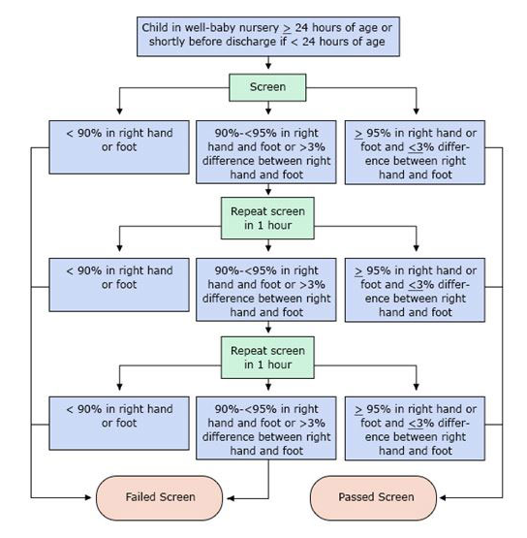
A screen is considered failed if:
- Any oxygen saturation measure is <90% (in the initial screen or in repeat screens),
- Oxygen saturation is <95% in the right hand and foot on three measures, each separated by one hour, or
- A >3% absolute difference exists in oxygen saturation between the right hand and foot on three measures, each separated by one hour.

Dermatology

Rash/Petechiae
Considerations:
- Where is the rash located?
- Describe lesion (pustular, vesicular, hyperpgimented, etc)
- Mother’s HSV status?

Differential:
- E. tox, Mongolian spots, neotatal acne, pustular melanosis, peeling skin, birth trauma, herpes
- Most things are benign!

Plan:
- If petechiae extensive or maternal ITP check platelet count
- Reassure parents
- If diaper rash order desitin
- See “herpes” in ID section
https://med.stanford.edu/newborns/professional-education/photo-gallery/skin.html

Ruddiness
- See polycythemia under the hematology section

FEN/GI

Breastfeeding
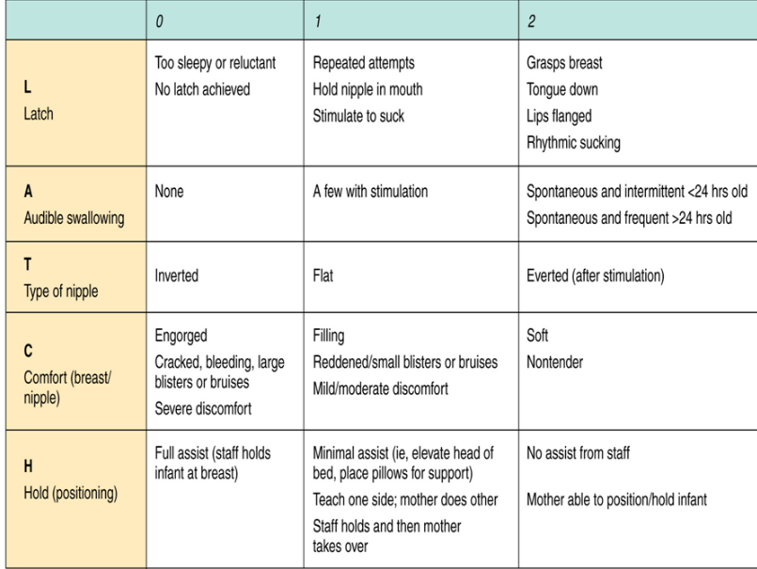
Contraindications for Breastfeeding
- Active HSV lesions on breast
- HIV + Mother
- Severe localized mastitis (purulent drainage)
- Maternal drug/EtOH use
- Active and untreated TB
- Human T lymphotrophic virus Type 1 or 2
- Active untreated varicella
- Medications (can use Lactmed website regarding lactation safety with any specific medication)
-Chemo
- ASA (especially high dose)
- Bromocriptine
- Abx: chloramphenicol, ciprofloxacin, metronidazole, tetracycline
- Cimetidine, gold salts
- Methimazole, thiouricil (decreases thyroid function)
- Opiates (may cause sedation)
- Amiodarone

Breastfeeding goals at OVMC:
- To promote breastfeeding in both the inpatient and outpatient maternal-child service by ensuring that, in the absence of contraindications, all mothers who elect to breastfeed will have a successful and satisfying experience.
- Breastfeeding policy routinely communicated to all healthcare staff, train all healthcare staff in benefits and breastfeeding management
- Inform all pregnant women about benefits of breastfeeding
- Help mothers initiate breastfeeding within 1hr of birth
  - Vaginal delivery: baby will be placed skin to skin immediately after birth or within 5 minutes, if infant and mother are stable.
  - C-section: If mother and baby are stable the baby will be kept in the OR with the mother. If possible, the baby will be placed on mother skin to skin and will be transported together to recovery
    - Once the mother is responsive and alert to the baby, she will be encouraged to keep her baby skin to skin and to begin breastfeeding within 1 hour or as soon as she is able.
    - If baby is unable to stay in the operating room and a responsible adult family member/support person is present, that person will be encouraged to initiate skin to skin with the baby until the mother is available to do so
- Show mothers how to breastfeed and maintain lactation
- Give newborns only breast milk unless medically indicated
- Practice “rooming-in”, allow mother and infant to remain together 24/7
- Encourage breastfeeding on demand, avoid artificial nipples/pacifiers
- Breastfeeding support groups, refer mothers to them at time of discharge

Diaper Count
Day of Life | Voids | Stools
1 | 1 | Black, tarry, mec
2 | 1-2 | Black, tarry, mec, or dark green
3 | 2-3 | Dark green or brown
4 | 4-6 | Brown-yellow, may be runny
5+ | 6-8 | Mustard yellow, runny and seedy

Hypoglycemia

Considerations:

- Routine monitoring of blood glucose is indicated for all at risk infants with the following conditions or symptoms of hypoglycemia:
  - SGA (<10%ile), LGA (>90%ile), LBW (<2500g), discordant twins (>10% below larger twin), preterm (<37 weeks), post-dates (>42 weeks), IUGR, IDM, non-IDM, sustained perinatal stress (Apgar <7 at 5 minutes; thick mec), sepsis, polycythemia, intrauterine exposure to terbutaline or propranolol within 2h of delivery
- Is baby lethargic, hard to arouse, diaphoretic, tachypneic, apneic, cyanotic, seizing, jittery, temp instability? Also consider checking blood sugar for irritability, exaggerated Moro, poor feeding.
- Hypoglycemia is defined as: BLOOD GLUCOSE < 45mg/dL
- A physician or neonatal nurse practitioner should be notified immediately of hypoglycemia even if the infant is asymptomatic.

Screening should be done within 60 minutes of birth in infants at risk for hypoglycemia or immediately in symptomatic infants.
  - Repeat sugars done within 1-2h of previous result till 4 consecutive blood sugars >45. Then 12HOL and 24HOL blood sugars
  - Blood sugar < 26 mg/dL: transfer to NICU
  - Blood sugar 26-44mg/dL: notify provider, administer glucose gel, breastfeed 1-5mL/skin-to-skin, recheck within 30min to 1hr
  - Blood sugar >45: continue skin-to-skin, hand-expression, recheck within 2h
Differential:
- Conditions that are risk factors for hypoglycemia plus
  - Sepsis
  - Metabolic abnormality (glycogen storage d/o, endocrine, increased circulating insulin, etc)
- If glucose below 50 after a few days of life, obtain critical labs per Endocrine:
  - Serum glucose, lactate, insulin, bicarb, beta hydroxy-butyrate
- If second episode of <50:
  - Serum glucose, free fatty acids, cortisol, growth hormone, urine organic acids

Bloody Stool
Considerations:
- Confirm peripheral perfusion and bowel sounds
- Gross blood? (from delivery or mom’s cracked nipples?)
- Occult blood? (swallowed blood, NG tube trauma, NEC)
- Streaks of blood? (anal fissure/tear, thermometer trauma)
- In there erythema or distention of abdominal wall? POing well?
Differential:
- Maternal blood (cracked nipples, during delivery)
- NG tube trauma
- Fissure
- Rectal trauma
- DIC
- NEC
- Volvulus
- Meckel’s
- Hirschprung’s
Plan:
- Order Apt test (differentiate maternal vs baby blood)
- Call NICU

Emesis
BILIOUS EMESIS IS MALROTATION WITH VOLVULUS UNTIL PROVEN OTHERWISE!! EMERGENCY!!
Considerations:
- What color is it (yellow, green, bloody?)? What is the volume?
- What was happening when it happened? (right after feed? Positional?)
- Check for bowel sounds and distension?
- Has the baby passed meconium?
- Can you pass an NG tube or delee?
- Is anus patent and in the right place?
- Was their exposure to magnesium?
- Was pregnancy complicated? (Polyhydramnios?)
Differential/Plan:
- Pass NG r/o esophageal atresia/web
- Anus not patent and/or in wrong position imperforate anus
- KUB shows no small intestine air duodenoal atresia/web, malro w/ volvulus, pyloric stenosis
- UGI Malro w/ volvulus, jejunoileal atresia
- Contrast enema to evaluate for Hirschprung’s, meconium ileus, meconium plug, congenital
microcolon
- Discuss with NICU

No stool (24 hours)
**98% of healthy FT babies will stool in the first 24 hours**
Considerations:
- Did mom get magnesium (paralytic ileus and delayed stool passage in baby)?
- Did baby pass meconium in the DR/OR? (check delivery note)
- Check for distension, bowel sounds, hernia, anal patency
- Is there emesis? PO feeding well?

Plan:
- If baby is well appearing may wait 24 more hours
- If not stool in 48 hours consider imperforate anus, Hirschprung’s, meconium plugs, ileal atresia or
meconium ileus
- Consider KUB
- Do NOT do rectal stim or suppository
- If exam abnormal alert NICU

Genetics
Are you concerned that the baby’s features are abnormal?
Considerations:
- Review history (FHx, Amnio results, triple screen)
- Physical Exam (look at parents too – do they have the PE finding that is concerning to you?)
- Assess stability of baby (VS, resp status, murmur, etc)
Plan:
- Be gentle and subtle with family (A nice question: Do you think the baby looks more like mom or dad?)
- Alert the attending of the findings
- If dysmorphism is obvious or family is concerned call NICU or Well baby attending for help

If concern for genetic condition, can place eConsult to Peds Genetics or email Dr. Julian Martinez. Consider chromosomal microarray following consultation with NICU attending. Can also consider karyotype to confirm suspected Trisomies, Turner syndrome, Klinefelter syndrome.

HEENT

Microcephaly
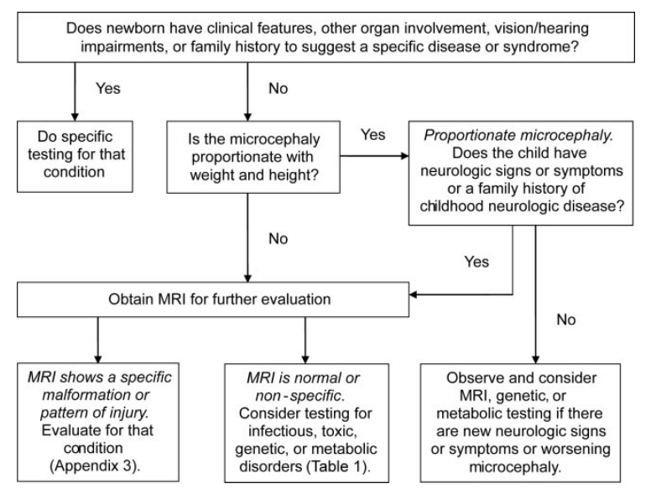

OV Specific: Please start with ultrasound evaluation prior to progressing to MRI.

Caput/Cephalohematoma/Subgaleal
Caput | Cephalohematoma | Subgaleal
- Crosses suture lines  - External to periosteum  - Edema associated with bruising and petechiae  - Resolves within days  - RF for hyperbilirubinemia | - Does NOT cross suture lines  - No discoloration of scalp  - Becomes apparent days later  - Can hide under a caput  - RF for hyperbiliruminemia | - Blood between galea aponeurotica and periosteum  - Diffuse skull swelling  - Fluid shifts with pressure  - Can spread towards the neck and ears  - Hypovolemic shock occurs rapidly (VS and head exam/HC q4 hours)

Short Tonuge/Tongue Tied
Clinical Criteria for short frenulum:
- Pull chin down and assess if tongue protrudes pass gum line, is able to touch palate and cheeks
- Assess breastfeeding and latch
Plan:
- Not an emergency, reassure parents
- Consider frenulectomy if unable to perform the actions above
- Future issues: impaired speech/articulation, poor dentition
ENT has been available to evaluate patients in-house and perform frenulectomy. Please page through amion (user name “ov im”) to speak with the consulting resident. Occasionally they have requested to bring the patient down to ENT clinic. If non-urgent, can also be scheduled outpatient through eConsult.

Eye Discharge
Considerations:
- Review mom’s chart for GC/CT and HSV
- Evaluate the sclera and conjunctiva for edema, erythema and discharge
Differential:
- Unilateral
  - Dacryostenosis: persistent tearing, mucoid, inner corner of eye
  - S. Aureus, P. aeruginosa, HSV, chemical
- Bilateral
  - GC presents at 48 hours, b/l purulent discharge 911! Can cause corneal perforation
  - CT presents at 4-10 days, b/l watery discharge
- Plan
  - Discharge copious or purulent send swab for gram stain (GC), Blood cultures, Viral cultures, and conjunctival scrapings for chlamydia and HSV
  - GC: CTX or topical erythromycin, eye irrigation q1-2 hours until clear, optho consult (can lead to blindness/perforation)
  - CT: Erythromycin suspension 12.5 mg/kg/dose PO QID x 14 days
  - Dacryostenosis: Warm compresses, reassure parents, if persists >6-10 months refer to optho

Hematology

Polycythemia
Normal: Hct 45-65He
Considerations:
- Risk factors: Twin-twin transfusion, IUGR, SGA, IDM, Placental insufficiency, In utero hypoxia, delayed cord clamping
- If baby is >48 hours old check I/Os and signs of dehydration
- Symptoms: Cyanosis, poor feeding, tachypnea, hypoglycemia, lethargic, jittery, weak suck

Plan:
- Check peripheral Hct and Glucose
  - Hct >65 + sx check central spun Hct
  - Hct >70 – sx check central spun Hct
- At risk for PPHN and ischemia

Infectious Disease
**All babies receiving antibiotics will go to NICU**

Septic/Sick Neonate
** Serial CRP needed for all infants undergoing R/O sepsis work-up. Minimum CRP x 2 (at 12hr, repeat at 36hr) that are WNL in order to discontinue antibiotics. For longer abx courses, continue to monitor serial CRP’s until within normal range.**

Chorioamnionitis:
- Maternal fever of ≥ 38⁰C (100.4⁰F) and at least two of the criteria:
  - Maternal leukocytosis (≥15,000 cells/mm3)
  - Maternal tachycardia (≥100 beats/min)
  - Fetal tachycardia (≥160 beats/min)
  - Uterine tenderness and/or
  - Foul odor of amniotic fluid
- The standard drug treatment in the mother with chorioamnionitis includes ampicillin and an aminoglycoside (ie, usually gentamicin), although clindamycin may be added for anaerobic pathogens

Triple I:
Terminology | Features and comments
Isolated maternal fever ("documented" fever) | Maternal oral temperature ≥39.0°C (102.2°F) on any one occasion is documented fever. If the oral temperature is 38.0°C (100.4°F) to 38.9°C (102.02°F), repeat the measurement in 30 minutes; if the repeat value remains at least 38.0°C (100.4°F), it is documented fever.
Suspected triple I | Fever without a clear source plus any of the following:  - Baseline fetal tachycardia (greater than 160 beats per min for 10 min or longer, excluding accelerations, decelerations, and periods of marked variability)  - Maternal white blood cell count greater than 15,000 per mm³ in the absence of corticosteroids  - Definite purulent fluid from the cervical os
Confirmed triple I | - All of the above plus objective laboratory findings of infection, such as^{Δ}:Positive amniotic fluid Gram stain for bacteria, low amniotic fluid glucose (eg, ≤14 mg/dL), high amniotic fluid white cell count in the absence of a bloody tap (eg, >30 cells/mm³), or positive amniotic fluid culture results, or  - Histopathologic evidence of infection or inflammation or both in the placenta, fetal membranes, or the umbilical cord vessels (funisitis)
Kaiser Sepsis Calculator (for infants >34 weeks GA): https://neonatalsepsiscalculator.kaiserpermanente.org
Incidence of EOS: 0.5 (CDC)
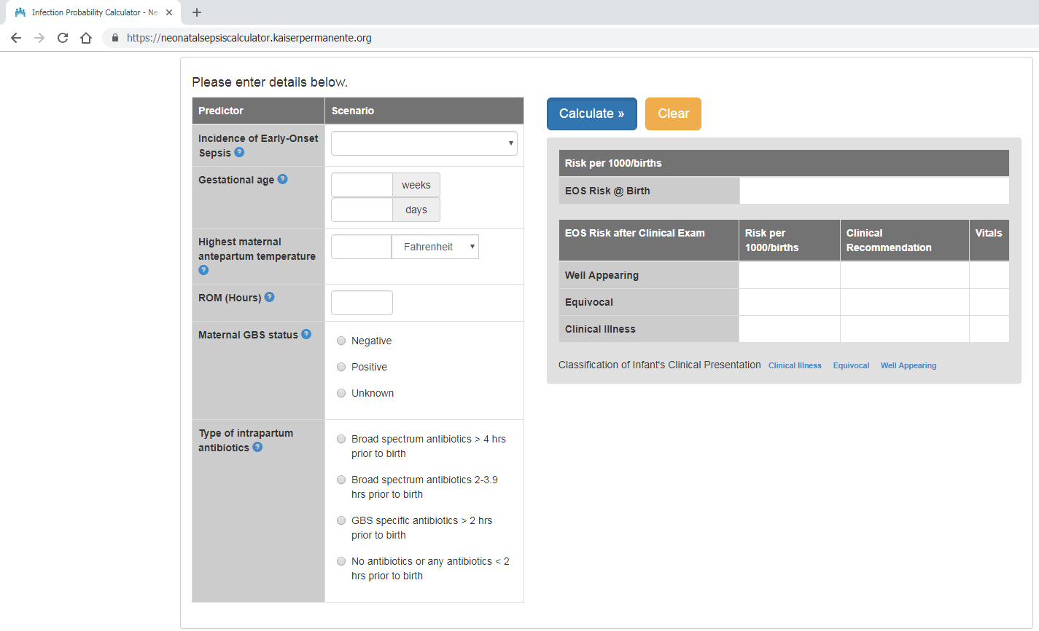

GBS Management
Prevention of GBS:
Intrapartum antimicrobial agents are indicated for the following situations:
  - Positive antenatal cultures or molecular test at admission for GBS (except for women who have a cesarean delivery without labor or membrane rupture)
  - Unknown maternal colonization status with gestation <37 weeks, rupture of membranes >18 hours, or temperature >100.4°F (>38°C)
  - GBS bacteriuria during the current pregnancy
  - Previous infant with invasive GBS disease

Targeted IAP:
- All pregnant women should undergo antepartum screening for GBS at 36 0/7–37 6/7 weeks of gestation, unless intrapartum antibiotic prophylaxis for GBS is indicated because of GBS bacteriuria during the pregnancy or because of a history of a previous GBS-infected newborn.
- All patients with positive GBS should receive IAP unless intact membranes and going to have cesarian delivery
- At-risk women include those who present in labor with a substantial risk of preterm birth, who have preterm prelabor rupture of membranes (PPROM) or rupture of membranes for 18 or more hours at term, or who present with intrapartum fever (temperature 100.4°F [38°C] or higher). If intraamniotic infection is suspected, broad-spectrum antibiotic therapy that provides coverage for polymicrobial infections as well as GBS should replace the antibiotic that provides coverage for GBS prophylaxis specifically

Hepatitis B
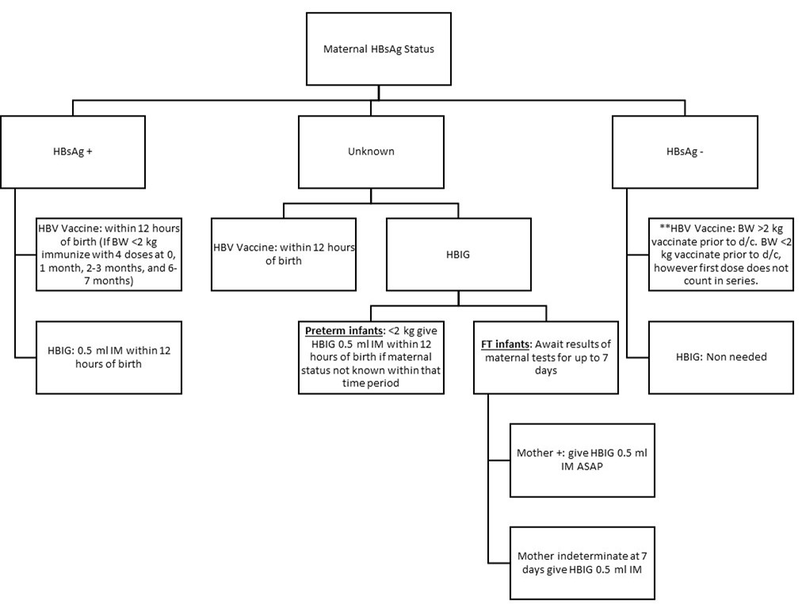

At OVMC we try and give HBV prior to 24HOL, it is usually done by evening shift.

Hepatitis C
Considerations:
- Review mother’s labs
- Maternal vertical transmission: The risk of transmitting the virus from an HCV-infected woman to her infant is approximately 5 percent. Transmission rates are higher if the mother is coinfected with HIV.
- Breastfeeding is NOT contraindicated, however should NOT breastfeed if nipples are cracked or bleeding (they should pump and discard till nipples have healed)
Plan:
Testing on baby:
- HCV RNA in two or more serum samples obtained at least three months apart during the first year of life (ideally between 2mo and 6mo of age). However, a positive result does not mean that the infant will remain infected, as there is spontaneous resolution of infection in a significant number of these children.
- Anti-HCV antibody in the infant after 18 months of age.

Rubella
Considerations:
- Is mom rubella immune? (check her prenatal labs)
Plan:
- If mom’s rubella status unknown ask OB to draw titers
- If mom is…
  - Immune do nothing
  - Non-immune ask OB to give mom rubella vaccine prior to discharge
- Immunization in the immediate post-partum period is not a contraindication to breast feeding

Herpes
Considerations:
- Active lesions? Primary or secondary outbreak?
- Is mother on suppression therapy? Since when?
- Was baby delivered by c/s or vaginal?
- How long was ROM?
- How does the baby look?
  - Vesicular lesion?
  - Signs of sepsis? Microcephaly?
Plans:
- Interview mom alone. Remember partner may not know mom’s HSV status.

Recurrent Active Lesion + Asx Baby | Primary Active Lesion | Remote Hx of Lesions and No Active Lesions at Delivery
- Infection rate: <5%  - Start contact precautions (baby can room in)  - Get cultures at 24 hours  - If baby symptomatic get cultures regardless of age and treat with empiric acyclovir | - Infection rate: 33-50%  - Start contact precautions (baby can room in)  - ?Watch and get cultures at 24 hours in asx baby vs immediate cultures and empiric tx in asx baby | - Not an indication for c/s  - Do not need cultures in asx baby, just observe

- Mom can breastfeed as long as breasts have no active lesions
- Cultures (DFA): Obtained from conjunctiva, nasopharynx, rectum and skin (if vesicle or lesion), also consider blood, urine and CSF

TB
Considerations:
- Review mother’s labs (PPD or Quant gold) and CXR status
- Is mom symptomatic? (cough, weight loss, night sweats)
Plan:
- If mom’s PPD is…
PPD +/Quant Gold + | PPD -/ Quant Gold -
- Ask OB to order CXR on mom  - If mom symptomatic mom and baby should be separated | Nothing to do

HIV Management at OVMC
MATERNAL HIV STATUS
- HIV UNKNOWN -> serologic testing in mother or infant. If mother is antibody positive, then follow algorithm below…
- HIV-infected mother — In neonate born to HIV-infected mother, serial testing is performed with an HIV virologic assay – orderable as HIV DNA pcr (on miscellaneous form). Timing of testing depends upon whether the infant is categorized as low- or higher-risk based on maternal prenatal care.
  - Low risk – Infants born to HIV-infected mothers who received standard antiretroviral therapy (ART) during pregnancy with sustained viral suppression (undetectable) and with no concerns related to maternal adherence
  - Higher risk – Infants born to HIV-infected mothers who did not receive standard care for HIV during pregnancy are at higher risk of perinatal transmission. This includes infants born to mothers living with HIV who:
- Did not receive prenatal care
- Did not receive antepartum or intrapartum antiretroviral therapy (ART)
- Received only intrapartum ART
- Were diagnosed with acute HIV infection during pregnancy
- Had detectable HIV viral load close to the time of delivery
- Received combination ART but did not have sustained viral suppression.
Mode of Delivery:
Strong recommendation:
- For women with HIV RNA levels > 1,000 copies/mL or unknown HIV level
  - Scheduled C-section at 38 weeks recommended irrespective of ART
  - If presenting in spontaneous labor or with rupture of membranes, insufficient evidence to determine whether C-section reduces risk of perinatal transmission
- For women with HIV RNA <=1,000 copies/mL
  - Scheduled C-section not routinely recommended, unless for obstetric indications
  - If on ART, duration of ROM not associated with increased risk of transmission -> vaginal delivery recommended
Testing of Infants:
Intervals for testing:
For low risk and high risk:
  - Two to three weeks
  - Four to eight weeks
  - Four to six months of age
For high risk infants:
  - Consider testing at birth (to determine timing of the infection if the infant is infected)
    - A positive result within the first three days of life reflects HIV infection in utero
    - Infants who have a negative initial test but test positive on subsequent tests were presumably infected peripartum.
  - Testing two to four weeks after cessation of antiretroviral prophylaxis (around 8-10 weeks)
- A positive result at any point should be confirmed as soon as possible with a repeat virologic test.
We have partnered with UCLA Care 4 Families Program. Please follow the recommended guidelines:
In addition to other routine NSY orders
- Please call 310-206-6369, or alpha page Dr. Deville (310-206-6639, pgr number #13803) to notify of admission. If after hours call 310-825-6301 and ask for the Pediatric Infectious Disease Attending on-call.
- Bather ASAP upon admission to NSY. Cleanse skin carefully prior to injections.
- NO BREASTFEEDING
- Medication
  - Standard prophylaxis for infant to start ASAP after birth, but before 12h of age
    - Zidovudine (AZT, ZDV, Retrovir) syrup (10mg/mL)
      - Dose 4mg/kg PO every 12 hours
    - Hepatitis B vaccine (Recombinant) Energix-B 10mcg (0.5mL) regardless of mother’s HBV status
      - Hepatitis-B immune globulin (HBIG) 0.5mL IM to be given ONLY if mother is HBsAg positive
  - Additional antiretroviral prophylaxis for HIGH-RISK infants (only after discussion with HIV team)
    - Lamivudine (3TC, Epivir) syrup (10mg/mL)
      - Dose 2mg/kg PO every 12 hours
    - Nevirapine (NVP, Viramune) syrup (10mg/mL)
      - Dose for full-term infants: 12mg PO. 1st dose DOL 0 (must be given with AZT). Second dose 48H after first dose, third dose 96H after 2nd dose.
    - Ralteglavir: Use in the event of known or strongly suspected maternal antiretroviral drug resistance. Since dosing regimen is so complex, it should be administered as inpatient
      - When the maternal antiretroviral regimen includes ralteglavir, the first dose to the newborn needs to be delayed by 24-48h depending on the timing of the mother’s last dose before delivery. This drug should not be given to infants with birth weight under 2kg.
      - Drug comes as a single-use packet of 100mg of ralteglavir suspended in 10mL of water, for a final concentration of 10mg/mL.
      - Once the dose is reconstituted it should be administered within 30min, the excess should be discarded.
      - Dose is 1.5mg/kg once a day for the first week, increasing to 3mg/kg twice a day subsequently.
- LABS draw with 24H NBS, Bilirubin (must be collected before 72HOL
  - HIV-1 Qualitative DNA PCR (1mL whole blood lavender top – min 0.5mL)
    - Unable to order on Orchid. QUEST: Use Miscellaneous order form. Setup Tuesday and Saturday
  - CBC with diff
  - AST/ALT
  - Creatinine
  - Urine
    - Routine Urinalysis (RUA)
    - CMV DNA Qualitative PCR
- DISCHARGE
  - During clinic hours call 310-206-6369 or page Dr. Deville (310-206-4173, pgr 13803) to schedule a follow-up appointment in CARE 4 FAMILIES Clinic.
  - Continue Zidovudine PROPHYLAXIS for baby’s first 6 weeks
  - Send prescription to OVMC Outpatient Pharmacy (x73066) for a 4 week supply of zidovudine syrup
  - DO NOT SEND PATIENT HOME WITH THE PRESCRIPTION. MOST PHARMACIES DO NOT CARRY ZDV SYRUP

Syphilis
- Please call 310-206-6369, or alpha page Dr. Deville (310-206-6639, pgr number #13803) for any questions regarding management. If after hours call 310-825-6301 and ask for the Pediatric Infectious Disease Attending on-call. Every baby will have an RPR done via cord blood. Syphilis is reportable to DPH.

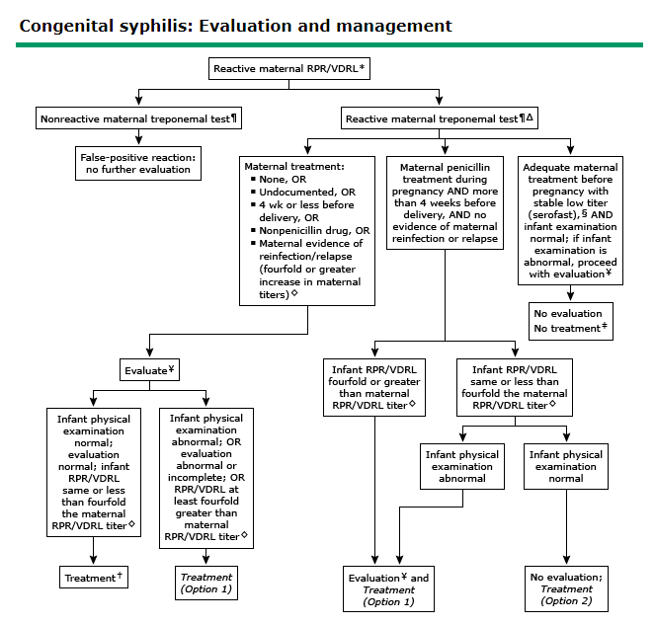

Temperature Instablity
Normal Temp: 36.5- 37.9
Considerations:
- Sepsis risk factors?
- Was baby out to mom? Was baby unwrapped?
- How long was the temperature drop?
- Is the baby feeding well? Alert?
- How are the vitals, perfusion?
Plan:
- Obtain a rectal temperature and place baby under the warmer recheck temperature in 30 minutes if baby is looking well (if not well appearing alert NICU and begin sepsis workup)
  - CBC, Blood Culture, consider LP

Muskuloskeletal

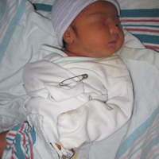
Clavicle
Considerations:
- Palpate clavicles (feeling for crepitus and/or step-offs)
- Is the Moro symmetric?
Plan:
- If exam is concerning or there is limited ROM b/l XR
- If there is a fracture pin the affected sides sleeve to the onesie and reassure parents

Hips
Considerations:
- Risk factors for developmental dysphasia of the hip (DDH):
  - FHx, female, breech presentation
- Clicks Barlow, unstable hip dislocating from acetabulum
- Clunks Ortolani, dislocated him reducing
  - Is the hip completely out at rest (dislocated)?
  - Is the hip partially out at rest (subluxed)?
  - Is the hip able to be pushed our all the way (dislocatable)?
  - Is the hip able to be partially pushed out (subluxatable)?
Plan:
- Urgent but not emergent
- Clunks need a hip US contact Peds Ortho (USC) and describe findings
- Clicks are controversial (may indicate ligamentous laxity)

Sacral Dimple
Considerations:
- Are gluteal folds symmetric?
- What is the exact location of the dimple (>2.5 cm from anal verge is concerning)?
- Can you visualize the base?
- What is the diameter (>0.5 cm concerning)?
Differential:
- Normal Baby
- Spina Bifida Occulta
- Low conus
- Tethered cord
- Fatty Filum
Plan:
- Not an emergency
- If dimple/tuft is at the coccyx or below do nothing
- Cannot visualize bottom of the pit sacral U/S
For sacral US, if sacral tract <5mm usually does not require follow-up or further imaging.) If spinal dysraphism is suspected, consider XR or MRI. Can consult Dr. Soni Chawla (x74863) for urgent recommendations. EConsult can be made to Peds Neurosurgery if deemed necessary, can consult with NICU attending.

Neurology

Floppy/Poor Feeder
Considerations:
- Check VS, tone (central and peripheral), reflexes, color, suck, I/Os
- Was baby more active before? What changed?
- Did mother get magnesium prior to birth?
- Did mother receive any opiods?
- Risk factors for sepsis?
Plan:
- Consider sepsis work up
- Look for physical exam findings consistent with trisomy 21
- If concerns for in utero narcotic exposure consider Narcan
- Call NICU

Seizure
Considerations:
- Check VS
- Distinguish between seizure and jitteriness (cannot stop seizure activity by holding the baby)
Differential:
- Day 1: Maternal anesthetic agents
- Day 2: Metabolic cause
- Day 2-3: Drug withdrawal, sepsis, meningitis
- Day 5+: Hypocalcaemia, TORCHs, “Benign 5th day fits”
- Consider brain bleed, particularly if Vit K was not given

Renal/GU

Bloody Urine
Considerations:
- What is the color and appearance of urine in the diaper?
Differential:
- If orange urate crystals (normal)
- If females, may be vaginal bleeding due to circulating maternal hormones (normal)
Plan:
- Send a UA to confirm

Hydronephrosis (Prenatal Diagnosis)
Considerations:
- Clarify prenatal history
- Are the kidney’s palpable?
Plan:
- Majority of hydronephrosis will self-resolve
- Repeat US to confirm pre-natal findings
  - If positive Consult peds renal (do not do VCUG or start ppx abx without discussing with renal)
  - If negative Small chance of false negative due to “relative dehydration” in first few days of life so repeat study at about 4 weeks of life

Abnormal Penis/HypospadiAs
Considerations:
- Has the baby voided?
- Does the foreskin balloon during urination?
- Where is the urethra (on glans, shaft, scrotum, perineum)?
- Is the penis curved (chordee) or cryptorchidism?
Plan:
- Consult urology
- Call NICU

No Urine (24 Hours)
Normal:
- 50% of FT babies urinate in first 8 hours
- Nearly 100% of FT babies will urinate in first 24 hours
Considerations:
- Examine urethra and foreskin
- Check baby’s PO intake and look for signs of dehydration
- Ask if parents have changed any wet diapers
- Check delivery note to see if baby voided in DR/OR
Differential:
- Dehydration, obstruction, b/l renal agenesis, renovascular accident
Plan:
- If not feeding well consider formula
- Massage the bladder to see if it can stimulate UOP (may take a few minutes)
- If still no urine call NICU and consider bladder scan, renal/bladder US, and/or catheterizing baby

Scrotal Problems

Considerations:
- Testes: Palpate and determine location
  - If you cannot feel testes in scrotum palpate inguinal canal
- Scrotum: Transilluminate, palpate and examine color
Differential:
- Testicular torsion, hernia (bowel in scrotum, reducible), hydrocele (peritoneal fluid in scrotum, nonreducible), undescended testes (3% of FT, 335 of preemies)
Plan:
- Blue/firm testis Testicular torsion STAT call peds urology and order testicular U/S w/ Doppler
- Swollen scrotum
  - Hernia that will be repaired as outpatient
  - Hydroceles resolve in 6-12 months if not, consider surgery
- Undescended testes:
  - Surgery sooner than later if there is an associated hernia
  - Many descend within one year so can watch and wait

Respiratory

Nasal Congestion/Can’t pass the NG TUbe
Considerations:
- Tolerating feeds?
- Cannot pass an NG tube? What size was used?
Differential:
- Mucus/meconium plugging, choanal atresia (cyanosis that disappears with crying), local tissue trauma, large tube
Plan:
- Congestion is normal in the newborn period, reassure parents
- If severe and/or interfering with feeds, try deep suctioning or nasal saline drops with bulb suctioning (nasal saline 1-2 drops each nare PRN 4 times a day for nasal congestion)
- Try 5 Fr tubing
- Call NICU

Stridor
Considerations:
- Examine work of breathing
- Check VS
Differential:
- Tracheomalacia
- Laryngomalacia
Plan:
- Check a pulse ox
- Consider CXR
- If in distress call NICU

Tachypnea
Considerations:
- C/S? Meconium? Risk factors for sepsis? Term?
- Examine the baby: Is it grunting, flaring or retracting?
- Count the respiratory rate yourself FOR ONE MINUTE (do not count for 6 seconds and multiply by 10)
- Check vitals
- Is there a murmur?
Differential:
- Onset is at or near birth: Transient tachypnea of the newborn (this can have a later onset and last until 72 hours of life, but typically very early on)
- Onset after 12 hours or severe distress:
  - Sepsis
  - Delayed transition
  - Pneumothorax
  - Meconium aspiration syndrome < Respiratory distress syndrome
  - Pneumonia
  - Tracheo-esophageal fistula
  - RDS associated with large baby (baby of mom with GDM and born before 38+4 may have delayed maturation of surfactant synthesis)
  - Congenital heart defect
Plan:
- Check pulse ox, glucose, hematocrit
  - Pulse ox should be >=94% on RA
    - If FT may be in low 90s if still transitioning
    - If <94% place baby under an O2 hood and wean as tolerated (in NICU)
  - Hematocrit
    - Normal: 45-65
      - If outside of normal call NICU
  - Glucose:
    - Is it normal for age (see “Hypoglycemia” section)
- Consider deep suctioning
- If persistent call NICU
- W/u: CXR, NG tube, ABD, CBC, Blood Cx

Social

Infant of Substance Abusing Mother
Considerations:
- Infant indicators of possible in utero drug exposure:
  - Preterm, IUGR, fetal alcohol syndrome, abstinence syndrome
- Prenatal maternal indicators of drug use:
  - Preterm labor, precipitous delivery, unexplained severe HTN, placental abruption, STDs, AMS, skin marks due to drug use, presence of drug paraphernalia
EAT, SLEEP, CONSOLE
  - Scoring every 4-6h
    - Does the newborn eat the expected amounts for gestational age?
    - Does the baby sleep at least 1 hour continuously when not disturbed?
    - Is the baby consolable within 10 minutes? What level of soothing support is needed?
  - Goal to optimize non-pharmacologic intervention (okay for prn doses of morphine after family-centered discussion), allow baby to room-in with mother, transfer from 3D postpartum to 4C peds if mother is being discharged and baby needs continued monitoring.
OVMC Neonatal Abstinence Syndrome or Neonatal Opiate Withdrawal Syndrome Management Pathway

- Neonatal Abstinence Syndrome or Neonatal Opiate Withdrawal Syndrome Management Pathway Scoring and Initial Management in Nursery
- 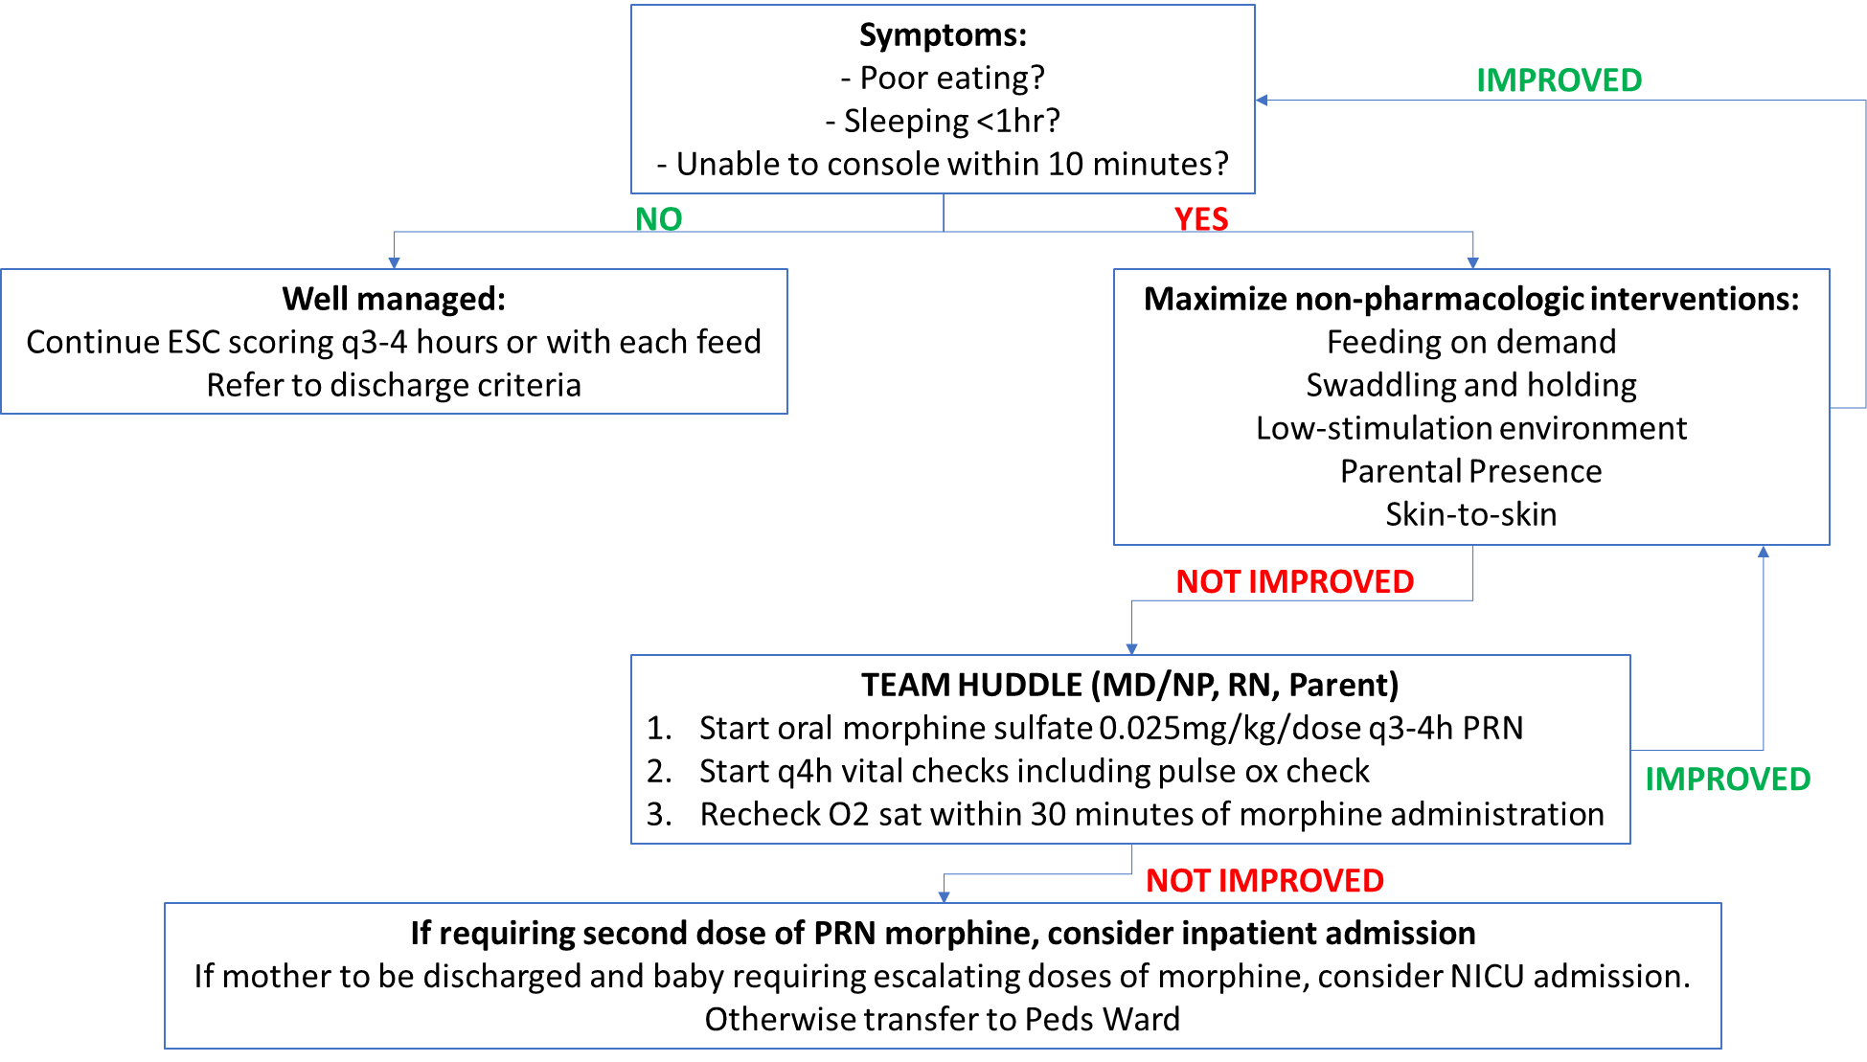

IUGR
Considerations:
- <10th percentile by weight; symmetric or asymmetric?
- Maternal medical causes: vascular disease, therapy, malnutrition, mechanical constraints, miscellaneous
- Stigmata of TORCHS? (HSM, petechiae, thrombocytopenia, ecchymosis, vesicle, rash, lymphadenopathy, hydrocephalus, microcephaly, cataracts, chorioretinitis)
- High incidence of perinatal distress, hypoglycemia, hypocalcemia and polycythemia

Plan:
- Check Hct and blood glucose
- Consider a developmental follow-up; evaluation to r/o chromosomal, genetic and congenital anomalies
- Consider evaluation of TORCHS infection:
  - Toxoplasmosis: Toxo panel on infant (IgG, IgM, IgA) and mother (IgG and IgM); treat with sulfonamide/pyrimethamine along with folic acid.
  - Other (varicella, mumps, parvovirus, HIV)
  - Rubella:>4 fold rise in Ab titers or seroconversion between acute and convalescent IgG serum tiers; no specific treatment, place into isolation
  - CMV: Urine CMV Cx, CBC, /LFT; treat with ganciclovir
  - HSV: review prenatals; get surface Cx ant 24h on baby (see “Herpes History in mom” under Infectious Disease section); treat with acyclovir
  - Syphilis: compare mother’s titer to infant’s titer (RPR); obtain CBC, LFT and long bone films
  - May result from being: ISAM, consider substance abuse panel
  - May result from placental insufficiency if asymmetric (HC>Length>Wt)

Antibiotic Dosing

Growth Chart

Mommy Talk
- Call the doctor or go to the ER for the following danger signs: ➢ Fever (>100.4F or >38C rectally)
  - Jaundice, looks yellow
  - Restless or continuous crying for no reason; cannot be comforted
  - Won’t wake to feed, refuses food for 2 consecutive feedings, decreased PO intake ➢ Green (bilious) or bloody emesis
  - Distended belly without relief after urination or BM
  - Has loose, watery stools 9more than three BM’s in a row
  - Has bleeding from any site
  - Has convulsions or jerking movements
  - Has an unusual rash
  - Persistent cough
  - Eye discharge >3 days
  - Blue baby or blue while feeding
- Feedings:
  - Breast or formula: Feed every 2-3 hours from the start of one feed to the start of the next. The goal is 8-12 times in 24h.
  - No additional water, other liquids or other foods necessary; feed on demand
- Sleeping:
  - Back to sleep
  - Discourage co-sleeping
  - Newborns sleep 16-20 hrs/day; 1-4 h sleep followed by 1-2 hrs awake periods
  - While asleep they will have periodic breathing (normal)
- Pooping and peeing:
  - Mushy stool for breastfed, and firmer for formula fed
  - Color transition from black and tarry to greenish to yellow
  - All babies strain a little when stooling; if the stool is soft, then not a problem.
  - In the newborn period, goal of 6-8 welt diapers per day; eventual BM frequency with each feed to once per 5-7d(formula) or 7d-10d (breast)
  - Avoid using rectal stimulation or placing suppositories
  - Wet diaper after most feeds
- Safety:
  - Rear-facing infant carseat
  - Avoid contact with sick people, remember good hand-washing
  - Avoid tobacco exposure 9increase risk of SIDS, asthma, etc.)
  - Don’t shake the baby
- Cord Care:
  - After diaper change, use clean water and Q-tip ; fold the top of the diaper down
  - Sponge bath until cord falls off
  - No lotion or soaps necessary (not dry skin, it’s normal postpartum exfoliation)
- Miscellaneous:
  - Dress baby in the same number of layers that the parents are wearing; use hat
  - Babies may have tiny breast buds and/or baby girls may have vaginal bleeding or clear- white discharge. Normal due to mother’s hormones.
  - Spit-up is normal, as is sneezing, hiccupping; if the nasal congestion is interfering with the feedings, try to suction with a bulb syringe along with nasal saline.

Resources
Care of a Well Newborn
Care of the Well Newborn. Lisa Stellwagen, Eyla Boies. Pediatrics in Review Mar 2006, 27 (3) 89-98; DOI: 10.1542/pir.27-3-89.
AAP Hyperbilirumin Clinical Guidelines
Lauer BJ, Spector ND. Hyperbilirubinemia in the Newborn. Pediatrics in Review. 2011; 32 ; 341.
AAP GBS Clinical Guidelines
Recommendations for the Prevention of Perinatal Group B Streptococcal (GBS) Disease. Pediatrics Volume 128, Number 3, September 2011.
AAP Hypoglycemia Clinical Guidelines
Postnatal Glucose Homeostasis in Late-Preterm and Term Infants. Committee on Fetus and Newborn. Pediatrics Mar 2011, 127 (3) 575-579; DOI: 10.1542/peds.2010-3851.
AAP Policy Statement on Male Circumcision
Circumcision Policy Statement. Pediatrics Sep 2012, 130 (3) 585-586; DOI: 10.1542/peds.2012-1989.
Birth Injuries
Gangaram Akangire, Brian Carter. Birth Injuries in Neonates. Pediatrics in Review Nov 2016, 37 (11) 451-462; DOI: 10.1542/pir.2015-0125.
Umbilical Cord Care
Dan Stewart, William Benitz. Umbilical Cord Care in the Newborn Infant. Pediatrics Sep 2016, 138 (3) e20162149; DOI: 10.1542/peds.2016-2149.
Vitamin K
American Academy of Pediatrics, Committee on Fetus and Newborn. Controversies Concerning Vitamin K and the Newborn. Pediatrics 2003 July; 112(1):191-2.
Meconium Stained Fluid
Meera Meerkov, Gary Weiner. Management of the Meconium-Stained Newborn. NeoReviews Aug 2016, 17 (8) e471-e477; DOI: 10.1542/neo.17-8-e471
Ambiguous Genitalia
Bonnie McCann-Crosby. Ambiguous Genitalia: Evaluation and Management in the Newborn. NeoReviews Mar 2016, 17 (3) e144-e153; DOI: 10.1542/neo.17-3-e144.
Respiratory Distress
Suzanne Reuter, Chuanpit Moser, Michelle Baack. Respiratory Distress in the Newborn. Pediatrics in Review Oct 2014, 35 (10) 417-429; DOI: 10.1542/pir.35-10-417
Physical Exam Resources
http://med.stanford.edu/newborns/professional-education/photo-gallery.html

